1. 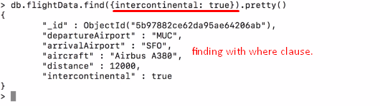
2. **Command**🡺Pretty() is not allowed for findOne({})🡸 As the returned one document is formatted automatically.  
   
3. 